**FRMS version 3.0.*, Installation instructions**

Note: If you do not have earlier version of FRMS installed on your computer start from step 4

The following instructions concern updating the FRMS desktop application to version 3.0.* The installation includes the following steps:

1. **Take a back-up file** of your local FRMS database in the following way: Copy the folder *C:\FRMS\FRMS-3.0.*\Postgres* with all the content to another location on your computer or external drive.
2. Make sure that all the entered data in your current FRMS desktop application have been synchronized to the central database. If not, synchronize the data by opening the FRMS Synchronization module from FRMS Control panel and synchronize the data with “Save and Load” button .

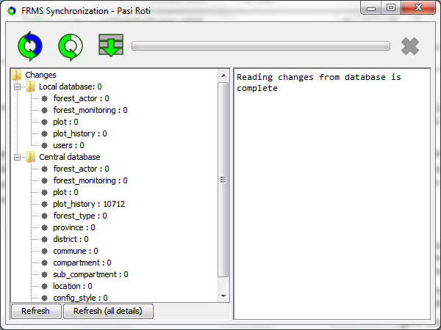

1. After the data have been synchronized to the central database (= the updated data is visible in the FRSM Web application), close all the FRMS components (Reporting Application, QGIS application and database) on your computer from the FRMS Control Panel.
2. Download or copy the installation program **FRMS-3.0.*.zip** to your local computer. The new version is available at <Inset the location of installatio package here>.
3. Extract the zip-file to your computer (preferably direct under the C: drive). The installation package extracts all the needed components of the FRMS version 3.0.* to your computer. The local database for the version 3.0.* is at this phase empty.
4. Start the installed FRMS version 3.0.* on your computer. In the FRMS Control Panel start first the Database.

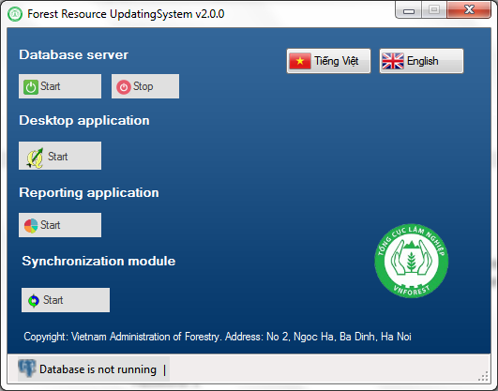

1. When database is started (you will see the text: Database is running on the lower left corner of FRMS Control panel) start Synchronization module.
2. Log in to the Synchronization module with user account:  
   User:<your user name>  
   Password: <your password>
3. Because the local database for the version 3.0.* is currently empty on your computer, the synchronization module requires you to run the Initial load to **load the data of your district(s) from the central to your local database**.  
   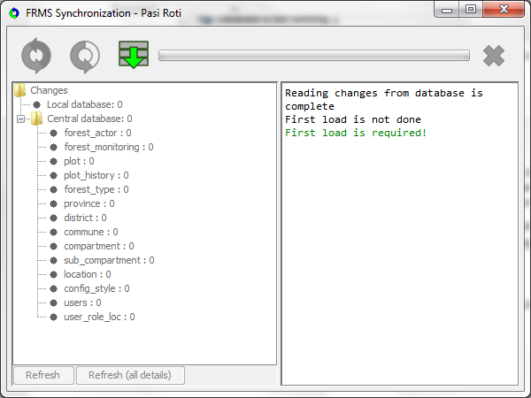  
     
   To do this,first start the synchronization by pressing the “*Initial Load*” button  in the Synchronization module. When the synchronization is running you can see the progress of the data loading in the synchronization window.  
   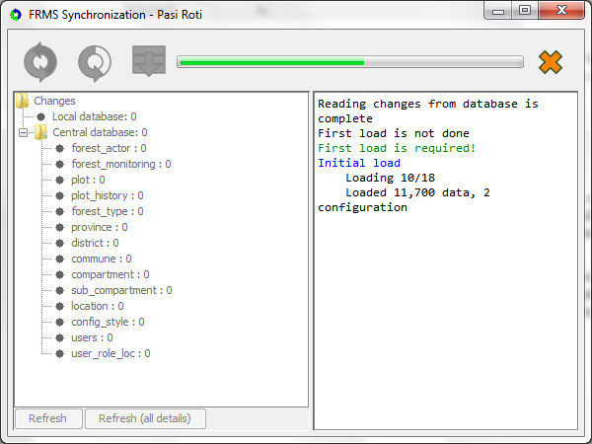
4. If you have satellite images available in the FRMS desktop application, copy the satellite raster image files from the old FRMS version folder *C:\...\FRMS-3.0.x\QGIS\apps\qgis\raster* to the new folder *C:\...\FRMS-3.0.y\QGIS\apps\qgis\raster*. This way the satellite images will be visible also in the new FRMS version.
5. Open the FRMS QGIS desktop version 3.0.*. When you can see the data in the QGIS and Reporting Application, the FRMS version 3.0.* has been installed successfully to your computer. Now you can continue the data entry and generating reports in the FRMS version 3.0.*